**BME2104 -《生物医学影像技术》Home Work #2**

Due Date: April 17, 2024

***Note:*** *Please prepare your answers to the problems in a single PDF, and upload your PDF to Blackboard.*

* 1. Iodine-based agent is commonly used in X-ray and CT imaging to enhance contrast. Applying the physics principle of X-ray and matter interactions, and if the X-rays are of monochromatic energy at 60 keV, please find the answers to the following:
     1. What is the wavelength and frequency of 60 keV x-ray photon?
     2. What is the relative x-ray absorption ratio of iodine to calcium which is the main element in bone?
     3. What is the K-edge absorption energy of iodine and calcium, respectively?

The K-edge absorption energy of iodine is 33169.4eV

The K-edge absorption energy of calcium is 4038.1eV

* + 1. At 60 keV, which one is the dominant interaction mechanism for total x-ray attenuation, absorption or scattering? Is there any chance of pair production at 60 keV?

The dominant interaction mechanism is usually the absorption. The pair production at 60keV is impossible because the energy of X-ray photons is typically too low to cause pair production.

* + 1. When incident X-ray is at 60 keV, how does the energy of Compton scattered x-ray depend on the scattering angle? Write down your equation, and then plot the scattering photon energy versus scattering angle.

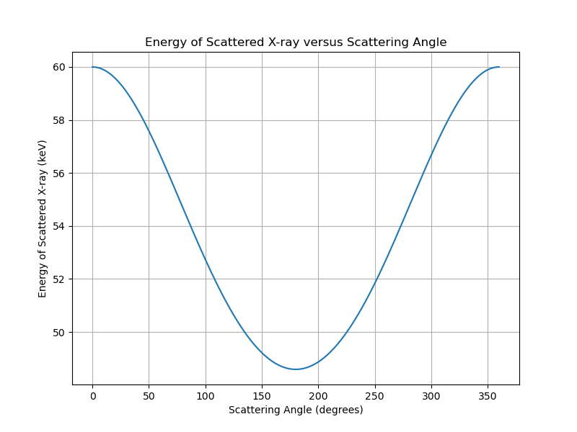

* 1. The spectrum from an x-ray tube is shown in the following figure. After the x-rays from this tube passed through a water cylinder (see right figure below), please sketch out the two expected x-ray spectra at the two positions (1 & 2). Please label those two spectra on the figure. You can superimpose your sketches onto the existing spectrum figure.

|  |  |
| --- | --- |
|  |  |

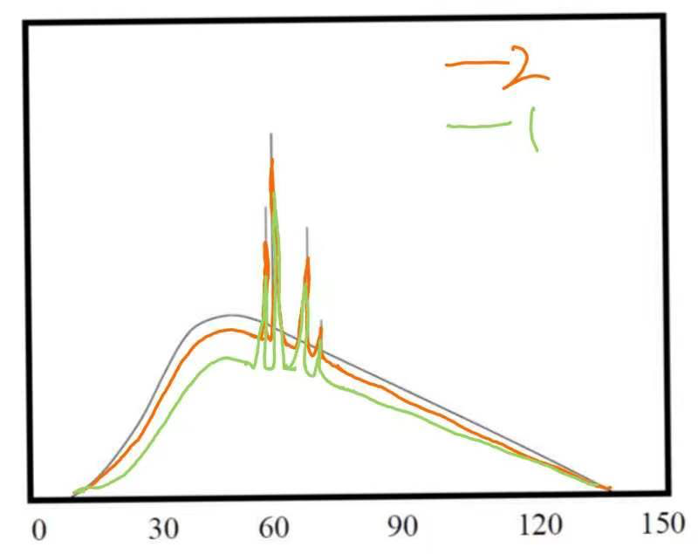

* 1. Use the following figure, explain the physics principle of Bremsstrahlung radiation, and how does Bremsstrahlung radiation contribute to the X-ray spectrum of an X-ray tube.

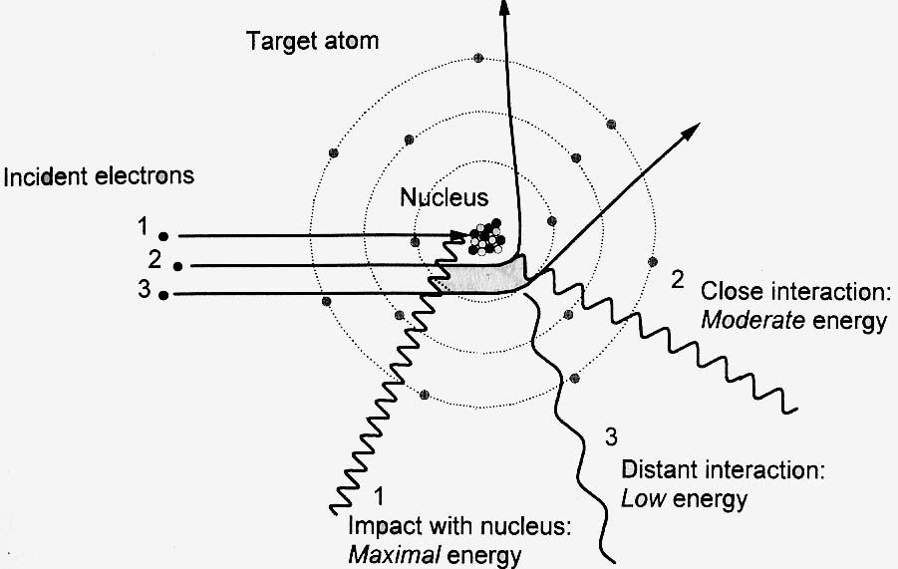

**The physics principle:**

1. **Maximal energy: Impact with the nucleus.** When the electrons interact directly with the nucleus, they experience the strongest deceleration, resulting in Bremsstrahlung radiation with maximal energy. These X-rays have high energy, corresponding to the maximum kinetic energy of the incident electrons.
2. **Moderate energy: Close interaction.** When electrons interact with the nucleus but do not directly come with it, they get moderate deceleration, producing Bremsstrahlung radiation with moderate energy.
3. **Low energy: Distant interaction.** When electrons interact with the nucleus at a distance, they experience less deceleration, resulting in Bremsstrahlung radiation with low energy.

All in all, electrons are accelerated from the cathode (negative electrode) to the anode (positive electrode) by a high voltage. When these electrons approach the positively charged nucleus of an atom in the anode material, they experience a strong electrostatic force that causes them to decelerate or change direction. As the electrons decelerate or change direction, they lose kinetic energy. According to the conservation of energy, this lost kinetic energy is converted into electromagnetic radiation, specifically X-rays, in the form of Bremsstrahlung radiation. The energy of the emitted X-rays in Bremsstrahlung radiation can vary widely, ranging from almost zero up to the maximum kinetic energy of the decelerating electrons. This results in a continuous spectrum of X-rays, with intensities decreasing as energy increases. The maximum energy of the emitted X-rays corresponds to the energy of the incident electrons.

Bremsstrahlung radiation significantly contributes to the X-ray spectrum of an X-ray tube through the following process:

1. **Generation of X-rays**: Electrons emitted from the cathode are accelerated towards the anode within the X-ray tube. Upon reaching the anode, these electrons interact with the target material, typically a metal such as tungsten.
2. **Bremsstrahlung Radiation Production**: As electrons rapidly decelerate within the target material due to the strong electric field of the atomic nuclei, Bremsstrahlung radiation is emitted. This occurs when electrons are deflected or slowed down by the electrostatic forces of the positively charged nuclei.
3. **X-ray Spectrum Formation**: The emitted Bremsstrahlung radiation contributes to the X-ray spectrum, which typically manifests as a continuous band of energies. This spectrum ranges from the maximum energy determined by the accelerating voltage applied to the X-ray tube down to zero energy, encompassing a wide range of X-ray energies. This continuous spectrum is characteristic of Bremsstrahlung radiation and is essential for various applications in X-ray imaging and analysis.
   1. What is characteristic X-ray of an X-ray tube? Please explain the physics principle behind characteristic X-ray.

When high-speed electrons collide with a material, they displace inner-shell electrons, creating vacancies. When outer-shell electrons transition to these vacancies, they emit X-rays. These X-rays are termed characteristic X-rays because different materials emit X-rays of varying wavelengths.

**Excitation of Atoms**: Upon collision with the target material, electrons can knock inner-shell electrons out of atoms, exciting the atoms from lower to higher energy levels.

**Electron Rearrangement:** Ejection of inner-shell electrons leads to rearrangement of electron structures within the atom. This rearrangement prompts outer-shell electrons to fill the vacancies left by the ejected electrons, elevating them to higher energy levels.

**Energy Release:** As outer-shell electrons fill the vacancies, they release energy.

**Unique Atomic Structure:** Each element possesses a distinct atomic structure, resulting in unique characteristic X-ray energy levels.

* 1. Is the following statement correct? Explain why.

Statement: The total Bremsstrahlung output of an x-ray tube depends on both the anode material and the anode voltage.

The statement is correct.

**Anode Material Variation**: The choice of anode material influences how electrons interact within the X-ray tube. Different materials possess unique atomic structures and nuclear charges, impacting the degree of interaction with the electron beam. Consequently, they produce varying levels of Bremsstrahlung radiation upon electron collision.

**Anode Voltage Impact**: Anode voltage plays a pivotal role in determining electron acceleration within the X-ray tube. Higher voltages lead to increased electron kinetic energies. As a result, electrons undergo more energetic collisions with the anode material. This heightened collision energy contributes to the generation of higher energy Bremsstrahlung radiation.

* 1. Based on the following graph, explain the line focusing principle, focal spot area, and effective focal spot.



1. **Line Focusing Principle:** Actual focal spot on the anode – the area of the target material being bombarded by electrons. And effective focal spot – the imaginary geometric line that can be drawn based on the actual focal spot size versus the anode takeoff angle.
2. **Focal Spot Area:** The focal spot area designates the specific region of the target on the X-ray tube where the electron beam is directed. When the electron beam strikes this region, it interacts with the target material, producing X-ray.
3. **Effective Focal Spot:** The effective focal spot represents the actual focal spot size achieved after implementing the line focus principle. It is calculated by multiplying the actual focal spot size by the sine of the anode angle. This adjustment optimizes the focal spot size, improving X-ray image resolution and detail.

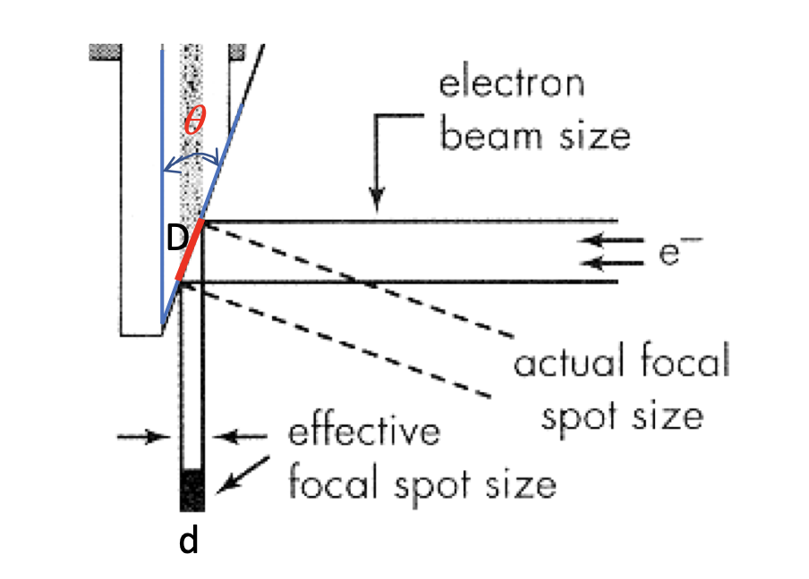

This figure shows the effective focal spot size is d*d,and the actual focal spot area on anode is d*D, and d = D*𝑠𝑖𝑛𝜃. So the effective focal spot size = the focal spot on area anode * 𝑠𝑖𝑛𝜃.

* 1. Based on the following graph, explain the cause of anode heel effect in an x-ray tube, and sketch out a possible x-ray intensity curve at the detector that shows the anode heel effect.

****The anode heel effect arises from the geometry and material composition of the X-ray tube's anode target. Specifically, it refers to the discrepancy in X-ray intensity between the cathode and anode ends of the target.

**Electron Interaction with Target**: High-energy electrons are directed towards the anode target. However, due to the angle of incidence, the target surface is not perpendicular to these electrons.

**Bremsstrahlung Radiation**: As the high-energy electrons collide with the target material, they interact with the atoms, generating bremsstrahlung radiation, which produces X-ray photons.

**Photon Attenuation**: Upon exiting the target surface, X-ray photons encounter the target material. Near the anode end, the target metal is thicker, leading to stronger attenuation of photons. Conversely, the target metal near the cathode end is thinner, resulting in weaker photon attenuation.

